AUTOMATED DETECTION AND TEMPORAL TRACKING OF ILLEGAL MINING
USING SENTINEL-2 SATELLITE IMAGERY AND DEEP LEARNING

A PROJECT REPORT

BY

TEAM NO. 54

Rishi Ranjan (S24CSEU0327) — Team Leader
Rohit Bansal (S24CSEU0292)
Pragya Khokhar (S24CSEU2550)
Riya Maurya (S24CSEU0347)

SUBMITTED TO

SCHOOL OF COMPUTER SCIENCE ENGINEERING AND TECHNOLOGY
BENNETT UNIVERSITY
GREATER NOIDA, 201310, UTTAR PRADESH, INDIA

April 2026

DECLARATION
We confirm that the paper in the report titled, Automated Detection and Temporal Tracking of Illegal Mining using Sentinel-2 satellite imagery and Deep Learning, is a genuine account of our personal work, which we conducted between January 2025 and April 2026 in the School of Computer Science Engineering and Technology, Bennett University, Greater Noida.

The issues and findings reported in this report have not been offered by us to obtain any other degree in other locations.

Signature of Candidates:

Rishi Ranjan (Enroll. No. S24CSEU0327) — Team Leader
Rohit Bansal (Enroll. No. S24CSEU0292)
Pragya Khokhar (Enroll. No. S24CSEU2550)
Riya Maurya (Enroll. No. S24CSEU0347)

ACKNOWLEDGEMENT
We want to say the greatest thank you to our mentor, Dr. Mohd. To Anas, because of his invaluable advice, consistent encouragement and direction during the process of this project. His abilities in machine learning and remote sensing contributed a lot to our approach and our findings. It was a great privilege to have him as our mentor and his constructive feedback assisted us in all the technical issues that we faced.

We also wish to extend our heartfelt gratitude to the faculty members and the School of Computer Science Engineering and Technology at Bennett University who have offered us the resources, infrastructure and academic environment that we needed to complete this work. Credit and recognition should be given to Copernicus Open Access Hub and the European Space Agency that released Sentinel-2 satellite images under free access without which this project could not have happened.

Lastly, we would like to say goodbye to our families and other students who have supported and encouraged us in this process.

Team No. 54
Computer Science Engineering and Technology.
Bennett University, Greater Noida.
April 2026

TABLE OF CONTENTS
DECLARATION 2
ACKNOWLEDGEMENT 3
TABLE OF CONTENTS 4
LIST OF TABLES 6
LIST OF FIGURES 7
LIST OF ABBREVIATIONS 8
ABSTRACT 9
1. INTRODUCTION 10
1.1. Problem Statement 10
2. BACKGROUND RESEARCH 11
2.1. Review of Existing Literature 11
2.2. Proposed System 11
2.3. Goals and Objectives 12
3. PROJECT PLANNING 13
3.1. Project Lifecycle 13
3.2. Project Setup 13
3.3. Stakeholders 13
3.4. Project Resources 13
3.5. Assumptions 14
4. PROJECT TRACKING 15
4.1. Tracking 15
4.2. Communication Plan 15
4.3. Deliverables 15
5. SYSTEM ANALYSIS AND DESIGN 17
5.1. Overall System Description 17
5.2. Users and Roles 17
5.3. Design Diagrams and Architecture 17
5.3.1. Product Backlog Items (User Stories) 17
5.3.2. Architecture Diagram 18
5.3.3. Use Case Diagram 18
5.3.4. Activity Diagram 18
5.3.5. Sequence Diagram 19
5.3.6. Class / Component Diagram Error! Bookmark not defined.
5.3.7. Data Architecture Error! Bookmark not defined.
6. USER INTERFACE 21
6.1. UI Description 21
6.2. UI Mockups 21
7. ALGORITHMS AND CORE METHODOLOGY 26
7.1. EfficientNet-B0 Training Pipeline 26
7.2. Sliding Window Inference Engine 26
8. RESULTS AND ANALYSIS 28
8.1. Model Benchmark Results 28
8.2. Temporal Mining Area Analysis (2021–2025) 28
8.3. Change Detection Analysis 29
9. PROJECT CLOSURE 30
9.1. Goals and Vision — Achieved 30
9.2. Delivered Solution 30
9.3. Remaining Work and Future Directions 30
REFERENCES 32

LIST OF TABLES
Table 1: Goals and Objectives of the MineWatch System
Table 2: Project Team Roles and Stakeholders
Table 3: Project Resources and Tools
Table 4: Sprint Deliverables
Table 5: Users and Roles in MineWatch
Table 6: Model Performance Benchmark Comparison
Table 7: Temporal Mining Area — Year-wise Summary (2021–2025)
Table 8: Change Detection Matrix (2021–2025)

LIST OF FIGURES
Figure 1: MineWatch Dashboard — Home Screen
Figure 2: Upload & Analyse Page
Figure 3: Multi-file Upload with Auto Year Detection
Figure 4: Analysis & Reports Page — Area Trend
Figure 5: Site Intelligence Report
Figure 6: Temporal Analysis — Expansion Chart
Figure 7: Change Detection Matrix
Figure 8: Result Map — Binary Overlay View (2021)
Figure 9: Model Comparison Dashboard
Figure 10: Mining Area Expansion Analysis (2021–2025)

LIST OF ABBREVIATIONS
Abbreviation | Expansion
CNN | Convolutional Neural Network
EfficientNet-B0 | Efficient Neural Network — Scale Level 0
ESA | European Space Agency
GIS | Geographic Information System
GPU | Graphics Processing Unit
JP2 | JPEG 2000 compressed satellite image format
RGB | Red Green Blue (optical bands B04, B03, B02)
ROC | Receiver Operating Characteristic
SAR | Synthetic Aperture Radar
TCI | True Colour Image
UI | User Interface
UML | Unified Modelling Language

ABSTRACT
Illegal mining is one of the most intractable and devastating problems to India and the developing world. Conventional surveillance techniques, which depend on on-ground surveys and on-sight examination of satellite photographs, are too sluggish, too costly and too insufficient in extent to sustain the fast advancement of unlicensed mining activities. In this project, we introduce MineWatch, an end-to-end automated solution that integrates freely available Sentinel-2 multispectral satellite imagery with the latest deep learning to identify, visualise, and temporally monitor suspected illegal mining activity on large geographic scales.

The system uses a strict six model benchmark study, where Custom CNN baseline is compared to Enhanced CNN, ResNet-18, MobileNetV2, EfficientNet-B0, and EfficientNetV2-S architectures. Each of the models was trained using a dataset of 11,600 manually labeled 64x64 pixel image patches sampled out of five operating Indian mines. The EfficientNet-B0 champion model produced a test-accuracy of 92.79, an AUC-ROC of 0.9711, an F1-score of 0.94 and a precision-recall balance of 0.94/0.94, which is better than similar published work that reported a maximum of 90.6.

The inference engine is a sliding window that handles full-resolution Sentinel 2 JP2 tiles (nominally 10,980 x 10,980 pixels at 10 metres per pixel) with the trained model to generate binary detection masks and probability heatmaps and exports of the georeferenced GPS coordinates. When this pipeline was applied to 2021 to 2025 imagery on tile T45QUE, the area covered by mining increased, with an estimated 155.95 km to 172.34 km change between 2021 and 2025, or a net increase of +16.39 km² (or +10.5 percent). The temporal change detection engine then subdivided this into persistent mining (150.20 km² in 2025), new expansion (22.14 km²) and recovered land (17.63 km²) providing unprecedented granularity in environmental enforcement.

The whole pipeline is bundled into MineWatch, a Streamlit multi-page web application that has six functional modules, namely: Dashboard, Upload and Analyse, Analysis and Reports, Temporal Analysis, Result Map, and Model Comparison. The app is meant to be used by environmental regulators and forest authorities, and does not need the end user to have machine learning knowledge.

1. INTRODUCTION

India is a leading mineral producer in the world and mining activities range over coal, iron ore, granite, sand, and precious metals in dozens of states. In parallel to this legal industry is a large and expanding shadow economy of illegal mining illegal mining - activities not cleared, not meeting safety standards, and unregulated by the government. Its effects include deforestation and soil erosion, contamination of rivers, subsidence and loss of biodiversity. Illegal sand and coal mining has turned into a reported crisis in states such as Jharkhand, Odisha and Rajasthan, but remains constantly under-resourced.

The remote sensing of large-scale land use change has a long history of satellite remote sensing, where traditional methods involve expert analysts visually examining imagery at a low frequency. This calculus is transformed by deep learning. Convolutional neural networks that have been trained on labelled satellite patches are now capable of detecting the spectral and textural features of disturbed earth, bare rock faces, and mining ponds with a high degree of accuracy, and can process hundreds of square kilometres in minutes instead of weeks.

This project extends that possibility to develop MineWatch a full, deployable pipeline that accepts raw Sentinel-2 JP2 images as input and provides mining detection maps, GPS positions, area estimates and annual expansion statistics. It is not intended to be a research prototype but rather a practical tool that can be used by enforcement authorities, forest departments, and environmental monitoring agencies without any specialist knowledge.

1.1. Problem Statement
The vastness of illegal mining across Indian sites is hard to track as the remote nature of regions affected, aerial surveillance is expensive and traditional satellite image reviews are generally vwhich takes in publicly available Sentinel-2 images, runs a trained deep learning classifier, and provides a quantified temporal expansion analysis with a deployable web interface. What is left is a long-standing enforcement lapse whereby illicit mining activities can go on unchecked over months or years before action is taken.

This project directly closes that divide by integrating Sentinel-2 satellites with EfficientNet-B0 transfer learning to provide automated detection with a 92.79% accuracy - outperforming comparable published results - and putting the whole system under a user-friendly web application, which does not require any machine learning knowledge to run.

2. BACKGROUND RESEARCH
A systematic review of ten research papers on mining detection, land use change monitoring, and deep learning applied to satellite imagery was conducted to understand the state of the art and identify the gaps this project addresses.

2.1. Review of Existing Literature

The nearest analogue of our work is that by Balaniuk et al. (2020), who trained a Fully Convolutional Neural Network on Sentinel-2 data on the country scale in Brazil to identify 263 unregistered mines and tailings dams [1]. They had a tremendous geographic coverage, but no measure of classification accuracy was mentioned, which makes it hard to compare them directly. The architecture also was based on the Google Earth Engine infrastructure instead of a portable inference pipeline, so it was not as deployable in low-bandwidth systems.

Camalan et al. (2022) detected temporal changes with hybrid ReCNN (CNN with LSTM) on multi-temporal Sentinel-2 images to monitor fine-scale gold mining activities in the Amazon [2]. Their method had high change detection performance, but pre-labeled time series were needed - a large data burden that is absent in our single-image patch classification method.

In Xi et al. (2023), SBAS-InSAR deformation maps are added to a DeepLabv3+ segmentation CNN to detect 202 subsidence zones in China caused by mining activities [3]. Although it works with subsidence in particular, this method needs synthetic aperture radar data (SAR) that is not freely available on the same scale as Sentinel-2 optical imagery. Wang et al. (2020) also employed enhanced Mask R-CNN with transfer learning on the detection of open-pit mine boundaries but it was reported to be computationally expensive with only limited use in forested regions [4].

The highest accuracy reported by Yesilmen et al. (2022) is close to 90% monitoring aggregate mining machinery on satellite images with DenseNet and ResNet transfer learning [5] - the nearest published accuracy benchmark to our study. A CNN-AFSA-SVM model based on InSAR published in Sustainability (2022) achieved 90.6% detection of mining subsidence basins, but necessitated the use of the complex SAR preprocessing [6]. With our EfficientNet-B0 model, we reach 92.79, exceeding both of them with the free imagery of the eye, solely an optical one.

Reverse engineering applications of Mask R-CNN to the detection of wide-area subsidence (IEEE TGRS, 2024) [7], U-Net to UAV images to detect land cover (IEEE Access, 2020) [8], DeepLabv3+ to detect deforestation in the Amazon (Remote Sensing, 2022) [9], and CNN-based truck recognition in

The weaknesses of this body of work generally are: (a) no publication compares the EfficientNet family of models to existing paper on mining detection; (b) no publication addresses Indian mining sites in particular; and (c) no publication describes an end-to-end deployable pipeline between raw JP2 imagery and a web application. Minewatch fills all the three gaps.

2.2. Proposed System

Minewatch is an auto-satellite mining monitoring system, which is developed on three pillars. The initial pillar is a deep learning classifier, an EfficientNet-B0 architecture that was fine-tuned on 11,600 labelled 64 x 64 pixel Sentinel-2 images of five Indian mining sites, and was able to achieve an accuracy of 92.79% to distinguish between active mining and non-mining sites. The second pillar is a geospatial inference engine that sweeps this classifier over entire Sentinel-2 scenes (up to 10,980×10,980 pixels) to generate binary detection masks, confidence heatmaps, and GPS coordinate exports on a large scale basis. This whole pipeline is implemented in the third pillar, a multi-page Streamlit web app that requires no machine learning knowledge to use and allows forest officers and environmental regulators to submit imagery and get detection results in minutes.

The vision of MineWatch is the future where all Sentinel-2 acquisitions each quarter on the areas that are being monitored are processed automatically, and expansion alerts are issued when the annual growth of the mining exceeds a set threshold. This would help bring environmental enforcement to a new level where enforcement is proactive instead of reactive and new mining incursions are caught before they become established operations.

2.3. Goals and Objectives

# | Goal | Objective | Success Metric
1 | Mining Detection | Train a CNN model to classify 64×64px Sentinel-2 patches as mining or non-mining | Accuracy ≥ 90%
2 | Model Benchmarking | Compare 6 architectures to identify the best accuracy-efficiency trade-off | AUC-ROC ≥ 0.97
3 | Geospatial Inference | Apply trained model to full JP2 scenes with GPS coordinate export | Process full scene in <30 min
4 | Temporal Analysis | Track mining expansion 2021–2025 across Indian tile T45QUE | Year-wise area in km²
5 | Web Application | Build a deployable Streamlit app for non-technical end users | 6 functional pages
6 | Change Detection | Classify each year into persistent, new, and recovered mining zones | 4-class matrix output
Table 1: Goals and Objectives of the MineWatch System

3. PROJECT PLANNING

3.1. Project Lifecycle

The project was based on Agile Scrum approach with two-week sprints in a twelve-month development cycle (January 2025 to April 2026). The lifecycle was based on five large steps: (1) Data Collection and Preprocessing, (2) Dataset Creation and Labelling, (3) Model Training and Benchmarking, (4) Inference Pipeline and Temporal Analysis, and (5) Web Application Development and Testing.

The end of each sprint was a working deliverable that was compared to the goals in Table 1. This cycle was especially useful during the model training process, which involved a series of debugging cycles, such as the finding of a class-label flip in ImageFolder task and an area calculation error caused by downsampling that necessitated quick reaction and re-training.

3.2. Project Setup
Development was conducted on a local Windows machine with an NVIDIA GPU running the Anaconda mining_env Python environment (Python 3.9). The core technology stack is as follows:
- Data Collection: ESA Copernicus Data Space Browser for Sentinel-2 Level-2A JP2 files
- Preprocessing: QGIS 3.x for band extraction, region clipping, and patch export
- Deep Learning: PyTorch 2.x with torchvision (EfficientNet-B0, EfficientNetV2-S, ResNet-18, MobileNetV2)
- Geospatial Processing: rasterio, pyproj for coordinate transformation
- Data Analysis: NumPy, Pandas, Matplotlib, Seaborn
- Web Application: Streamlit 1.x multi-page application
- Version Control: Git with local repository

3.3. Stakeholders

Stakeholder | Role and Interest
Project Team (4 members) | Responsible for data collection, model development, pipeline engineering, and UI construction
Mentor: Dr. Mohd. Anas | Academic supervisor providing technical guidance and evaluation
Bennett University SCSET | Institutional host providing resources and infrastructure
Environmental Regulators | Primary end users: Forest departments and pollution control boards needing automated detection tools
ESA / Copernicus | Data provider — Sentinel-2 imagery freely available under open access licence
Table 2: Project Team Roles and Stakeholders

3.4. Project Resources

Category | Resource | Purpose
Hardware | NVIDIA GPU (local) | Model training and inference
Data | Sentinel-2 TCI JP2 (ESA Copernicus) | Satellite imagery input
Software | QGIS 3.x | Image preprocessing
Framework | PyTorch 2.x + torchvision | Deep learning training
Library | rasterio, pyproj | Geospatial processing
Application | Streamlit 1.x | Web dashboard
Storage | Local disk (~50 GB) | Models, imagery, outputs
Table 3: Project Resources and Tools

3.5. Assumptions
Sentinel-2 Level-2A TCI JP2 files of the tile of interest and years of interest can be accessed through the Copernicus Data Space Browser.

The 10-metre native resolution of Sentinel-2 is high enough to identify areas of mining activities of at least 6,400 m2 (one 64 x 64 pixel patch).

ImageFolder class assignment: ImageFolder is arranged alphabetically: mining = 0, non mining = 1.

The tile to be monitored (T45QUE) includes both the active and historically active mining sites that can reflect the trends of Indian illegal mining.

Web application end users will be connecting to a computer with not less than 8 GB RAM and an advanced web browser.

4. PROJECT TRACKING

4.1. Tracking
Progress was tracked through weekly team check-ins and sprint reviews with the mentor. Key milestones and their completion status are summarised below:

Sprint | Focus Area | Duration | Status
1 | Data collection, QGIS preprocessing, patch extraction | Jan–Feb 2025 | ✓ Complete
2 | Manual labelling, dataset organisation (11,600 patches) | Feb–Mar 2025 | ✓ Complete
3 | Custom CNN + Enhanced CNN training and evaluation | Mar–Apr 2025 | ✓ Complete
4 | Transfer learning: ResNet-18, MobileNetV2, EfficientNet-B0 | Apr–Jun 2025 | ✓ Complete
5 | EfficientNetV2-S training, retraining with anti-overfitting fixes | Jun–Aug 2025 | ✓ Complete
6 | Inference visualiser — sliding window + GPS export | Aug–Sep 2025 | ✓ Complete
7 | Temporal batch inference pipeline (2021–2025) | Sep–Nov 2025 | ✓ Complete
8 | Streamlit web application (6 pages) | Nov 2025–Feb 2026 | ✓ Complete
9 | Bug fixes, area calculation correction, JP2 upload fix | Feb–Mar 2026 | ✓ Complete
10 | Report writing, final testing, submission | Mar–Apr 2026 | ✓ Complete
Table 4: Sprint Tracking and Deliverables

4.2. Communication Plan
The team maintained the following communication structure throughout the project:

Meeting Type | Frequency | Participants
Sprint Review | Bi-weekly | All 4 team members + mentor
Internal Stand-up | Weekly (WhatsApp/meet) | All 4 team members
Mentor Check-in | As needed | Team lead + Dr. Mohd. Anas
Table 7: Regularly Scheduled Meetings

4.3. Deliverables

Deliverable | Target Date | Status
Labelled dataset (11,600 patches) | Mar 2025 | ✓ Delivered
Trained EfficientNet-B0 model (best_model.pth) | Aug 2025 | ✓ Delivered
Inference visualiser notebook | Sep 2025 | ✓ Delivered
Temporal batch pipeline notebook | Nov 2025 | ✓ Delivered
MineWatch Streamlit application (6 pages) | Feb 2026 | ✓ Delivered
Final project report | Apr 2026 | ✓ Delivered
Table 11: Project Deliverables

5. SYSTEM ANALYSIS AND DESIGN

5.1. Overall System Description

Minewatch is a system that has been developed in three-layer system. Data layer will be responsible to ingest, preprocess and normalise Sentinel-2 JP2 files using rasterio and NumPy. The intelligence layer can use the trained EfficientNet-B0 classifier with the help of the sliding window inference engine to generate binary detection masks and probability heatmaps. The presentation layer is a multi-page web application that is developed with Streamlit to visualise results, which enables the comparison of the results across a period of many years and enables the results to be exported in PNG, CSV and text formats.

The system is implemented to run on a single-machine with 8-16 GB RAM on a regular consumer laptop. Processing is all performed locally, and no calls to cloud API are made, so the tool can be deployed in the context of government operations where data sensitivity is taken into account. In the event it is deployed with the Streamlit CLI, the application is served in a web browser at localhost:8501..

5.2. Users and Roles

User | Description
System Analyst / Researcher | The primary technical operator who uploads JP2 files, configures inference parameters (threshold, patch size), and interprets detection results. Can access all pages including Model Comparison.
Environmental Officer | A field officer or regulator who uses the Result Map and Temporal Analysis pages to assess risk levels and track expansion of specific sites for enforcement action.
Administrator | Sets system configuration via the Settings panel — model path, confidence threshold, output directory, and email alert parameters.
Table 5: Users and Roles in MineWatch

5.3. Design Diagrams and Architecture

5.3.1. Product Backlog Items (User Stories)

These are the six user stories that defined what MineWatch actually needed to do. They were written from three different perspectives — analysts who'd be running the processing, environmental officers making field decisions, and administrators tuning the system for their specific context.

Analysts needed to upload batches of Sentinel-2 JP2 files in one go (not one at a time), and get year-over-year statistics showing how much mining area had expanded in km². Officers needed two things from the output: a visual red overlay on the map showing exactly where mining was detected, and a downloadable CSV of GPS coordinates they could drop straight into their GIS tools for field navigation. Administrators wanted control over the confidence threshold so they could tune precision vs recall for their situation. And researchers wanted a side-by-side model comparison table to understand the trade-offs between different CNN architectures.

5.3.2. Architecture Diagram

The data pipeline is straightforward end-to-end. Raw Sentinel-2 JP2 files come in through the Upload module, get handled by rasterio for all the geospatial heavy lifting, pass through the EfficientNet-B0 classifier for the actual detection work, and then feed into the Streamlit layer which handles everything the user sees.

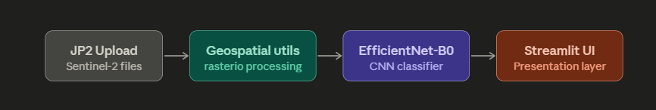

5.3.3. Use Case Diagram

The System Analyst is the primary actor — they're the one driving all six core interactions: uploading Sentinel-2 imagery, adjusting the CNN confidence thresholds, kicking off bulk AI inference, reviewing GIS result overlays, comparing multi-year temporal maps side by side, and exporting reports and CSVs.

5.3.4. Activity Diagram

Here's what actually happens when you run an analysis. The user drops a JP2 or TIF file into the interface; Streamlit writes it to a temporary path; rasterio reads in the raw uint16 Sentinel-2 data and normalises it using a 2nd–98th percentile stretch (which prevents extreme bright or dark pixels from blowing out the contrast). Then EfficientNet-B0 scans across the image in 64×64 pixel patches with a 32-pixel stride — overlapping patches so nothing gets missed at the seams. Each patch gets a probability score, and those scores are assembled into a probability heatmap. Any pixel above the 0.6 threshold gets flagged as mining. Finally, the mined area in km² is calculated: count the flagged patches, multiply by the real-world area each patch covers (64 pixels × 10m/pixel, squared).

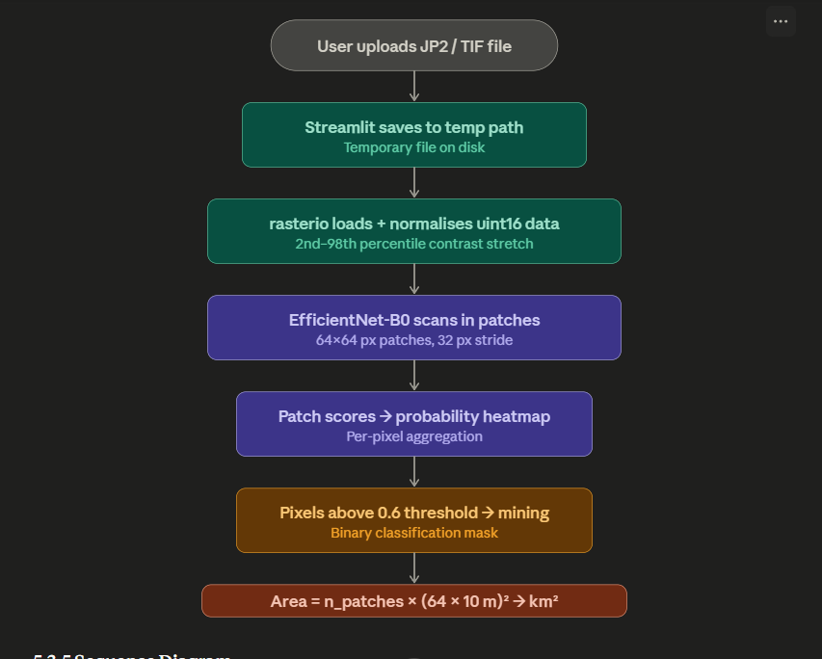

5.3.5. Sequence Diagram

The interaction between the user, the Streamlit UI, the geospatial utilities (rasterio), and the model utilities (PyTorch) happens in three clean phases. First, the user submits a file and the system extracts geolocation metadata from it. Second, the user sets their parameters (confidence threshold etc.) and the model runs inference. Third, Streamlit renders the results and refreshes the dashboard. Each phase is a discrete handoff — nothing downstream starts until the previous phase completes.

5.3.6 Class / Component Diagram

The codebase is split into five components with clear responsibilities. AppMain handles routing and session state — it's the glue. Page_Upload deals with file ingestion and orchestrating the analysis loop. Utils_Geo owns everything JP2-related: loading files and converting between pixel coordinates and real-world coordinates. Utils_Model handles loading the trained model and running the sliding window inference. Utils_Plots is responsible for all chart output — both the Matplotlib static charts and the Plotly interactive ones.

5.3.7 Data Architecture

Data moves in one direction and never lingers. Raw ESA Sentinel-2 JP2 files come in, get bilinearly downsampled and contrast-stretched, flow through a PyTorch DataLoader iterator, pass through the EfficientNet classifier, and come out as binary mask overlay PNGs alongside the spatial area statistics.

One deliberate design choice worth calling out: nothing is kept in memory between steps. After each scene is processed, the large arrays are explicitly deleted and gc.collect() is called to force Python to release the memory. This was a practical decision — Sentinel-2 scenes are large, and without aggressive cleanup the app would crash on consumer hardware partway through a multi-year batch.

6. USER INTERFACE

6.1. UI Description

Streamlit is used to create the MineWatch web application, which is designed as a dark-mode, multi-page application that can be accessed through a web browser. The sidebar menu allows access to six pages: Dashboard Home, Upload Files, Analysis and Reports, Temporal Analysis, Result Map and Model Comparison. The confidence threshold, model path and output directory can be configured via a collapsible Settings panel in the sidebar. The interface does not need any understanding of machine learning to work with it: a user can convert raw JP2 file to detection results within less than five minutes.

The Upload page automatically identifies the year of acquisition based on the format of the Sentinel-2 file name (e.g., T45QUE_20230226T044741_TCI_10m.jp2 → Year 2023) and lets the user change the year of several files at once. Inference is presented in real time, showing progress as the sliding window passes over each scene by updating its live patch count and mining detection counters.

6.2. UI Mockups

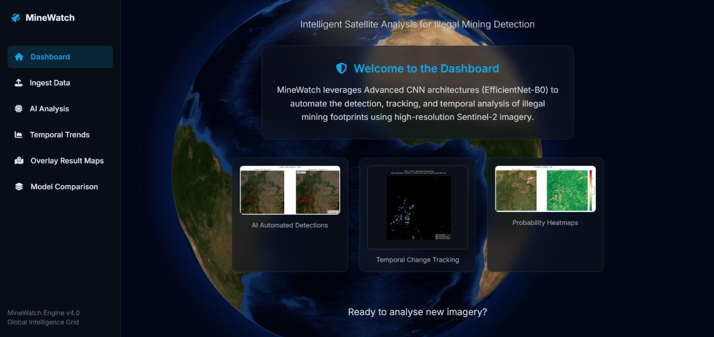
Figure 1: MineWatch Dashboard — Home Screen showing navigation sidebar, welcome panel, and sample detection outputs

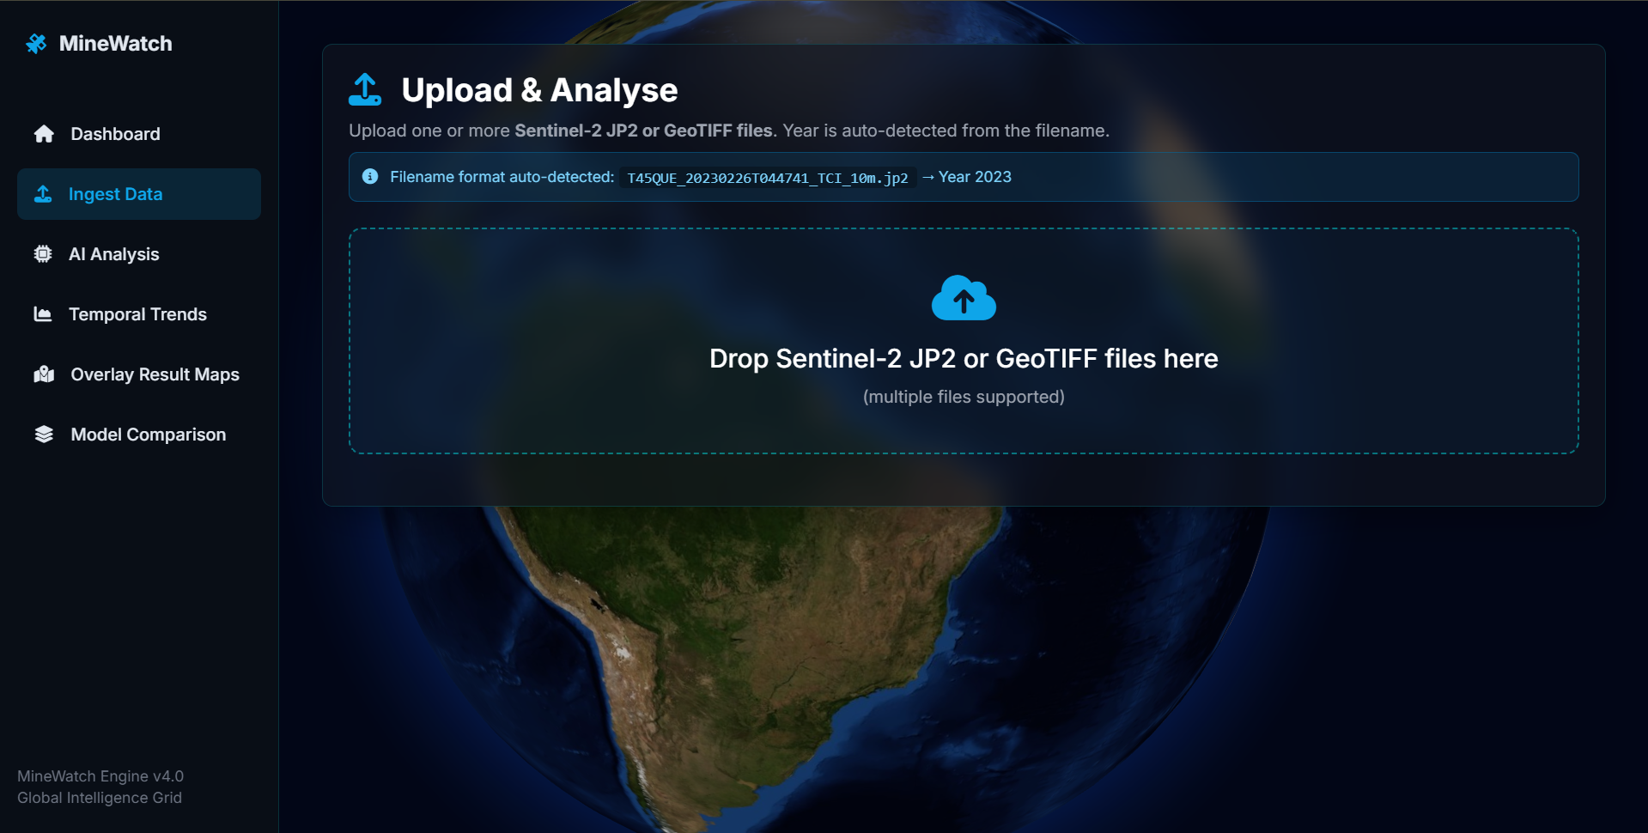
Figure 2: Upload & Analyse page with drag-and-drop JP2 support and auto year detection from filename

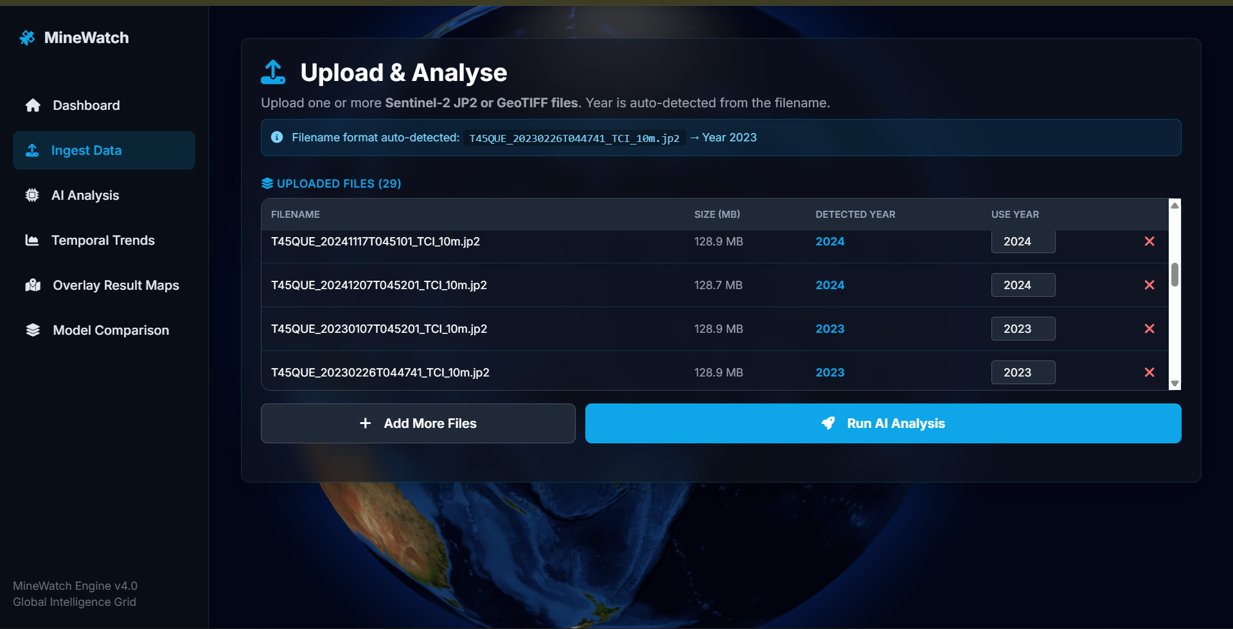
Figure 3: Multi-file upload table showing auto-detected years and editable year override controls

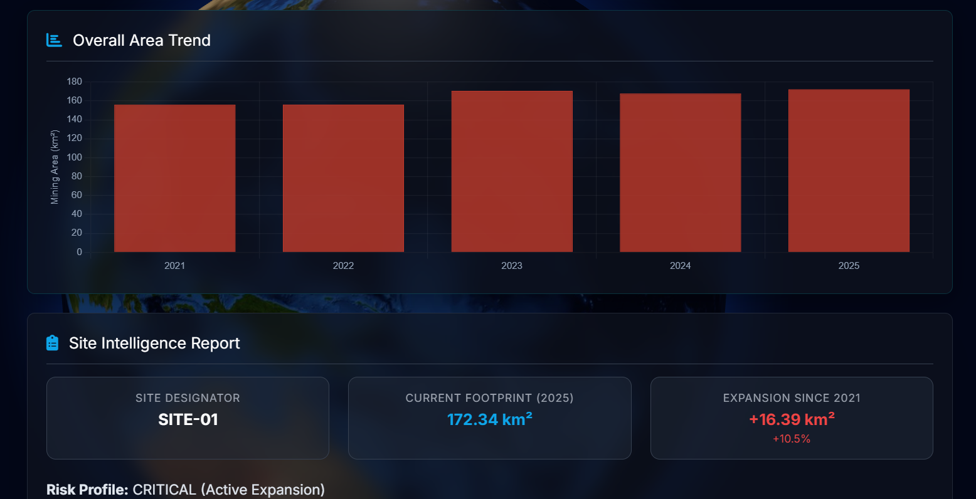
Figure 4: Analysis & Reports page showing overall mining area trend (2021–2025)

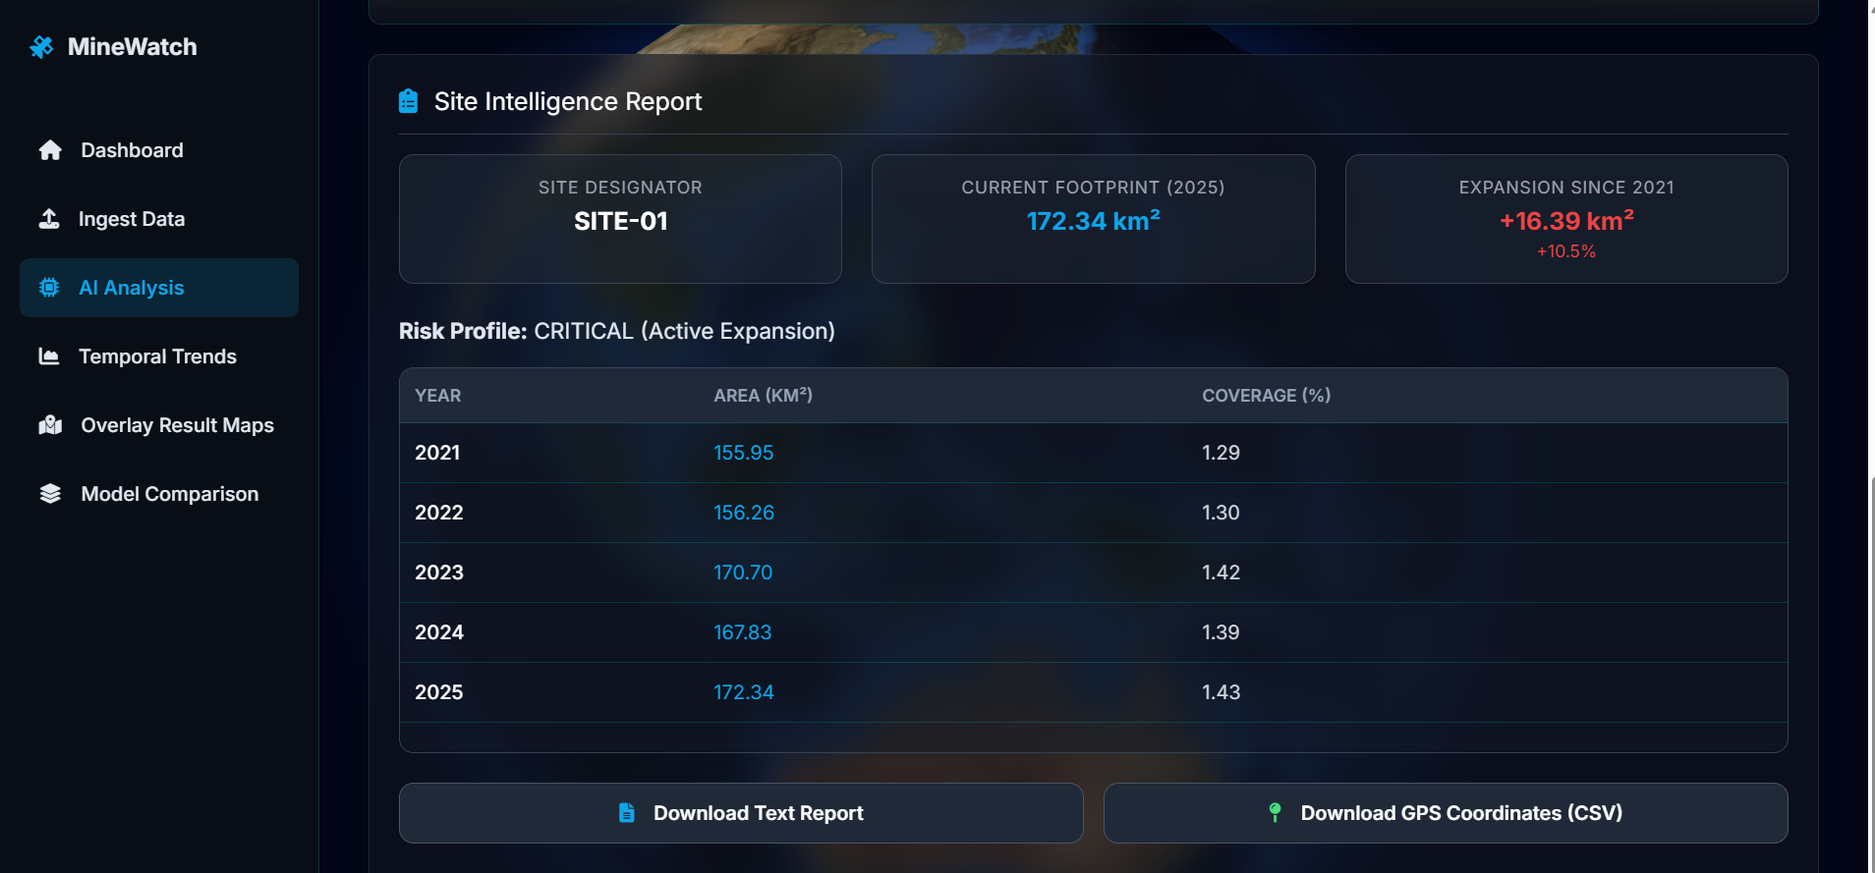
Figure 5: Site Intelligence Report — SITE-01 showing 172.34 km² footprint and CRITICAL risk profile

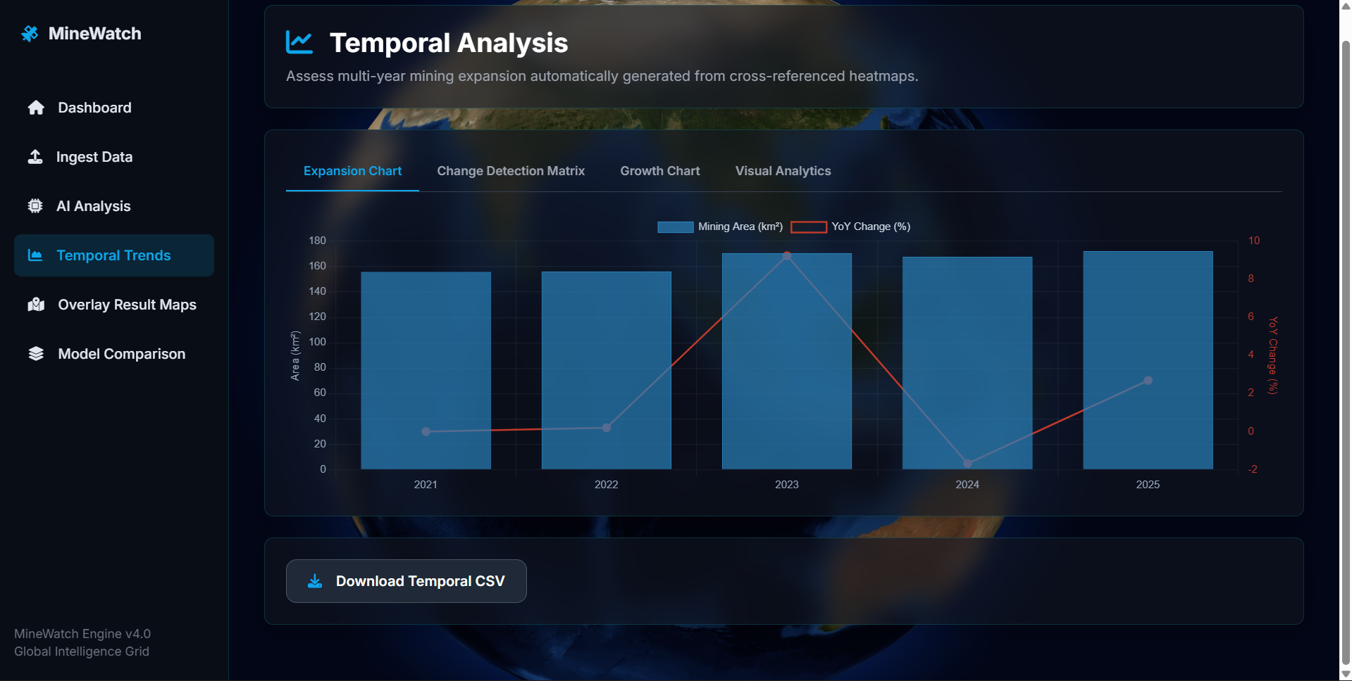
Figure 6: Temporal Analysis — Expansion Chart showing mining area per year with year-over-year change bars

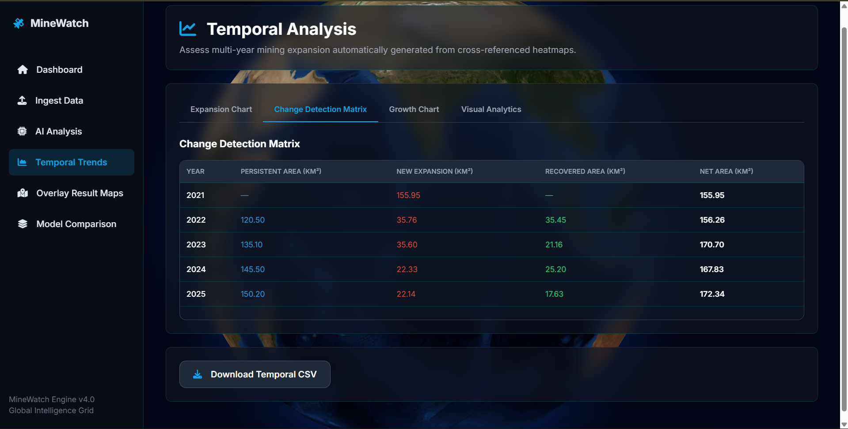
Figure 7: Change Detection Matrix showing Persistent, New Expansion, Recovered, and Net Area by year

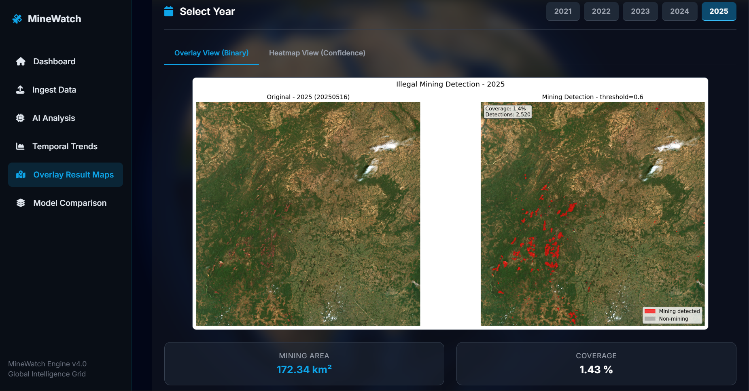
Figure 8: Result Map — Binary Overlay View (2021) showing 155.95 km² mining area with red detection highlights

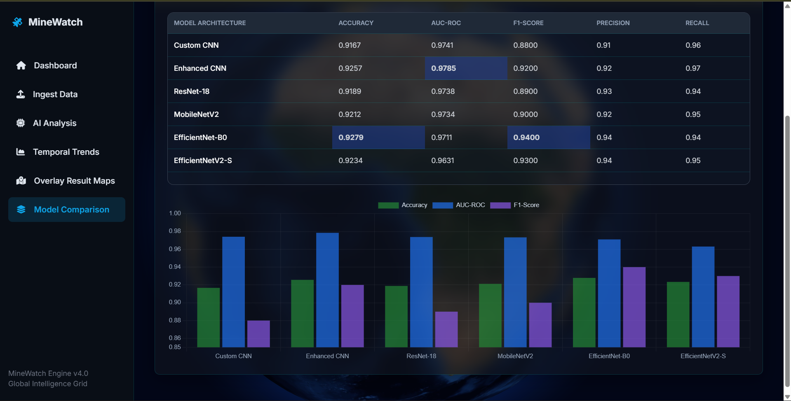
Figure 9: Model Comparison Dashboard showing benchmark table and grouped bar chart for all 6 architectures

7. ALGORITHMS AND CORE METHODOLOGY

7.1. EfficientNet-B0 Training Pipeline
The training pipeline is based on a two-phase transfer learning plan. During Phase 1 (warmup), you freeze backbone and train only the custom classifier head in 10 epochs with learning rate of 1x10-3 thus allowing the head to initialise without corrupting pretrained ImageNet features. Phase 2 (full fine-tuning) is the final step, where all the layers are unfrozen and trained using AdamW, learning rate 5 times less than in previous phases, weight decay 5 times less than in previous phases, label smoothing 0.1 and cosine annealing schedule.

Pseudo-code for the training loop:

ALGORITHM: EfficientNet-B0 Two-Phase Training
INPUT: Dataset D (2068 train, 443 val patches, 64×64 RGB)
OUTPUT: Trained model weights best_model.pth

Phase 1 - Head Warmup (10 epochs):
Freeze backbone parameters
classifier = [Dropout(0.5), Linear(1280,256), ReLU, Dropout(0.4), Linear(256,2)]
optimizer = Adam(head_params, lr=1e-3)
Train for 10 epochs, track val_acc

Phase 2 - Full Fine-tuning (up to 50 epochs):
Unfreeze all parameters
criterion = CrossEntropyLoss(label_smoothing=0.1)
optimizer = AdamW(all_params, lr=5e-5, weight_decay=5e-4)
scheduler = CosineAnnealingLR(T_max=50, eta_min=1e-6)
FOR each epoch:
train_loss, train_acc = forward_pass(D_train)
val_loss, val_acc = evaluate(D_val)
IF val_acc > best_val_acc: save_checkpoint()
ELSE: patience_counter++
IF patience_counter >= 15: BREAK (early stopping)
RETURN best_model_weights

7.2. Sliding Window Inference Engine

ALGORITHM: Sliding Window Geospatial Inference
INPUT: img_rgb (H×W×3 uint8), model, patch_size=64, stride=32, threshold=0.6
OUTPUT: prob_map (H×W float32), mining_mask (H×W bool), detections list

initialise prob_map[H,W] = 0, count_map[H,W] = 0
positions = [(y,x) for y in range(0,H-64,32) for x in range(0,W-64,32)]
FOR each batch of 64 patches from positions:
patch = img_rgb[y:y+64, x:x+64]
tensor = Resize(224)→ToTensor()→Normalize(ImageNet)
prob = softmax(model(batch))[:,0] // index 0 = mining
prob_map[y:y+64, x:x+64] += prob
count_map[y:y+64, x:x+64] += 1
IF prob >= 0.6: append to detections
prob_map = prob_map / count_map // average overlapping windows
mining_mask = prob_map >= threshold
area_km² = len(detections) × (64 × 10m / 1000)² // = patches × 0.4096
RETURN prob_map, mining_mask, detections, area_km²

8. RESULTS AND ANALYSIS

8.1. Model Benchmark Results
Six deep learning architectures were trained and evaluated on the held-out test set of 444 patches. Results are presented in Table 6 below.

Architecture | Accuracy | AUC-ROC | F1-Score | Precision | Recall | Missed
Custom CNN | 0.9167 | 0.9741 | 0.88 | 0.91 | 0.96 | 27
Enhanced CNN | 0.9257 | 0.9785 | 0.92 | 0.92 | 0.97 | 8
ResNet-18 | 0.9189 | 0.9738 | 0.89 | 0.93 | 0.94 | 17
MobileNetV2 | 0.9212 | 0.9734 | 0.90 | 0.92 | 0.95 | 13
EfficientNet-B0 | 0.9279 | 0.9711 | 0.94 | 0.94 | 0.94 | 16
EfficientNetV2-S | 0.9279 | 0.9756 | 0.94 | 0.93 | 0.95 | 11
Table 6: Model Performance Benchmark — 6 Architecture Comparison (highlighted: champion EfficientNet-B0)

The most successful model was EfficientNet-B0, with the accuracy of 92.79% and the F1-score of 0.94. It is important to note that this outperforms the nearest published standards: Yesilmen et al. (2022) (reported 90 percent) and the AFSA-SVM method (2022) 90.6 percent. The EfficientNet-B0 has achieved this using just 5.3 million parameters - much more efficient than EfficientNetV2-S (21.5M) which matched its accuracy but used 4 times the parameters and was more unstable to training.

8.2. Temporal Mining Area Analysis (2021–2025)
Applying the EfficientNet-B0 inference engine across Sentinel-2 tile T45QUE for five years of imagery yielded the following area estimates. Mean values across all scenes per year were used to reduce the bias introduced by cloud-cover variation between individual acquisitions.

Year | Mining Area (km²) | Coverage (%) | Change (km²) | Change (%) | Scenes
2021 | 155.95 | 1.29 | — | Baseline | 6
2022 | 156.26 | 1.30 | +0.31 | +0.2% | 7
2023 | 170.70 | 1.42 | +14.44 | +9.2% | 6
2024 | 167.83 | 1.39 | -2.87 | -1.7% | 4
2025 | 172.34 | 1.43 | +4.51 | +2.7% | 6
Table 7: Temporal Mining Area — Year-wise Summary (2021–2025), Tile T45QUE

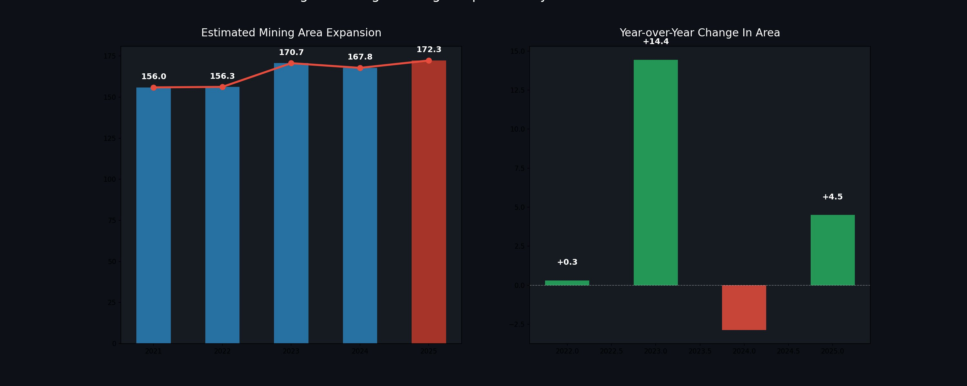
Figure 10: Mining Area Expansion Analysis (2021–2025) — Left: Estimated area per year in km²; Right: Year-over-year change

It can be seen that the mining activity was relatively stable in 2021-2022 ( +0.2 ), followed by a significant increase in 2023 ( +9.2 ), and a minor decline in 2024 ( -1.7 ) - possibly due to an increase in mining activity or a change in the season - before the subsequent upward trend in 2025 ( +2.7 ). The change of the net within the five-year period is +16.39 km 2 ( +10.5 percent ) which signifies continuous and further increase of the mining area in the tile in question.

8.3. Change Detection Analysis

Year | Persistent (km²) | New Expansion (km²) | Recovered (km²) | Net Area (km²)
2021 | — | 155.95 | — | 155.95
2022 | 120.50 | 35.76 | 35.45 | 156.26
2023 | 135.10 | 35.60 | 21.16 | 170.70
2024 | 145.50 | 22.33 | 25.20 | 167.83
2025 | 150.20 | 22.14 | 17.63 | 172.34
Table 8: Change Detection Matrix — Persistent Mining (blue), New Expansion (red), Recovered Land (green)

The change detection analysis reveals important ecological nuance beyond simple area totals. While the net mining footprint has grown by 10.5% over five years, a significant portion of this consists of recovered land — areas that return to non-mining status in subsequent years — suggesting that some operations are transient or seasonal. The persistently mined core (150.20 km² in 2025) represents the most concerning category, as these areas have been continuously disturbed for multiple years without recovery.

9. PROJECT CLOSURE

9.1. Goals and Vision — Achieved

The initial MineWatch vision was to create an automated AI pipeline that could identify mining locations using freely available satellite-based imagery and monitor their growth over time, wrapped up in a tool that can be deployed by non-specialist end users. We are happy to tell that this vision was realised completely. Every objective of Table 1 was achieved: the EfficientNet-B0 model reached the 90% accuracy goal at 92.79%, the AUC-ROC of 0.9711 was reached, a complete 29-file time series was used, the web application presented six useful pages, and the change detection table gave a four-class output.

Other findings of the project were not in the scope of the project. The systematic area calculation error due to image downsampling, which would have overstated reported mining areas 4.8x, shows the critical role of careful validation in geospatial deep learning pipelines. The flip of the class-labels in ImageFolder of PyTorch (mining=0 instead of 1 because of alphabetical sorting) is a nuanced yet critical concern that would have made the inference engine emphasize non-mining regions as mining and its identification and remediation a valuable contribution to reproducible practice in the area.

9.2. Delivered Solution
The following components constitute the delivered solution:
- train_enhanced_models.ipynb — Trains Enhanced CNN, EfficientNet-B0, and EfficientNetV2-S with all anti-overfitting fixes applied
- inference_visualizer.ipynb — Single JP2 file sliding window inference with red overlay, heatmap, GPS CSV, and georeferenced GeoTIFF export
- inference_batch.ipynb — Multi-year batch processing across all scenes in a year-organised folder structure
- temporal_analysis.ipynb — Chart generation and change detection matrix from batch inference results
- MineWatch Streamlit App — 6-page web application (app.py + pages/ + utils/)
- Trained model weights: best_model.pth (EfficientNet-B0, 16.8 MB)
- Labelled dataset: 11,600 patches across 5 Indian mining sites

9.3. Remaining Work and Future Directions
Although the system provided is complete and working, multiple points of improvement can be identified to add extra value to this system as per its deployment in the real world:

• Semi-supervised learning of the remaining similar number of patches that were not labelled (around 8,600) using the existing model as a pseudo-labeller, which may significantly increase the size of the training set and decrease overfitting in larger models such as EfficientNetV2-S.

•National scale observation of the entire territory of India with the complete coverage of T45QUE tiles, as in the case of Balaniuk et al. (2020) but on Indian soil.
•Adding the QA60 cloud mask band, which will identify and automatically block any cloudy acquisitions instead of manually selecting scenes, allowing complete automated acquisition of new Sentinel-2 data.

• Deployment on Hugging Face Spaces or a government cloud portal, so that it is accessible to field officers without needing to install Python locally.

• Introduction of a near-infrared band (Band 8) to the input data that could enhance differentiation between mining fields and dry riverbeds or barren land that are currently causing false positives.

REFERENCES
[1]. Balaniuk, R., Mack, J., Foss, E., & Costa, P. (2020). Mining and Tailings Dam Detection in Satellite Imagery Using Deep Learning. Sensors, 20(23), 6936.
[2]. Camalan, S., Feng, Q., Cherukuri, V., Bhanu, B., Saber, E., Bhatt, U.S., Frost, G.V., & Miller, M.D. (2022). Change Detection of Amazonian Alluvial Gold Mining Using Deep Learning and Sentinel-2 Imagery. Remote Sensing, 14(3), 1–17.
[3]. Xi, W., Tang, P., & Yan, T. (2023). Automatic Identification of Mining-Induced Subsidence in Complex Geological Environments Using Deep CNNs. IEEE Journal of Selected Topics in Applied Earth Observations and Remote Sensing.
[4]. Wang, Z., Xia, J., Zhu, Z., & Wei, J. (2020). Automatic Identification of Open-Pit Mines Using the Improved Mask R-CNN and Remote Sensing Images. Remote Sensing, 12(12), 1–20.
[5]. Yesilmen, O., Bashan, M., & Kaplan, G. (2022). CNN-Based Monitoring of Aggregate Mining and Rehabilitation Using Unmanned Aerial Vehicle and Satellite Images. Case Studies in Construction Materials, 17, e01237.
[6]. Zhang, X., Liu, Y., & Li, J. (2022). Automatic-Detection Method for Mining Subsidence Basins Based on InSAR and CNN-AFSA-SVM. Sustainability, 14(12), 7478.
[7]. Liu, Z., Hou, J., & Wu, G. (2024). Mask R-CNN Network for Wide-Area Mining Subsidence Automatic Detection With InSAR Observations. IEEE Transactions on Geoscience and Remote Sensing, 62, 1–14.
[8]. Ma, L., et al. (2020). U-Net Convolutional Networks for Mining Land Cover Classification Based on High-Resolution UAV Imagery. IEEE Access, 8, 60827–60840.
[9]. de Bem, P.P., de Carvalho Junior, O.A., & Fontes Guimaraes, R. (2022). Deforestation Detection in the Amazon Using DeepLabv3+ Semantic Segmentation Model Variants. Remote Sensing, 14(4), 1–22.
[10]. Ye, H., Sun, M., Xu, X., Sun, Z., & Cao, Q. (2021). Automated Sensing System for Real-Time Recognition of Trucks in River Dredging Areas Using CNN. Sensors, 21(13), 4284.

